MATH 282 Final Exam Study Questions
  - Complexity and private and public keys
- Suppose that sorting a list can be done in O(n * log₂ n) time.
  - If you have an unsorted list, how long would it take (in big-O notation) to sort the list and then find one item in the list using a binary search? Explain.
It would take O(n * log n) to sort and O(log n) to do the binary search, so the total steps would be n*log n + log n. Because log n is so much smaller than n*log n (ignore lower orders of complexity), this process would be O(n*log n).
  - How does the process above (sorting and then using the binary search) compare to just using a sequential search on the unsorted list?
A sequential search would be O(n), which is smaller than O(n*log n), so a sequential search would be faster than sorting and then doing a binary search.
  - If you have an unsorted list, how long would it take (in big-O notation) to sort the list and then do n/2 different searches on the list using a binary search?
It would take O(n * log n) to sort and then n/2 * log n to do the searches, so the total steps would be n*log n + n/2 * log n. Ignoring constants (/2), that’s n*log n + n*log n = 2*n*log n, which means we can ignore the constant 2 and the process would be O(n*log n).
  - How long would it take (in big-O notation) to do n/2 different searches using a sequential search on the unsorted list, and how does this compare to sorting and then using a binary search?
To do n/2 searches using a sequential search on the unsorted list would take O(n) steps for the search multiplied by n/2 searches = n * n/2 = n² / 2 steps, so O(n²). This would be slower than sorting and then using a binary search, which is O(n * log n).
- Bob wants to receive secret messages from Alice. He chooses RSA for the job with p = 13 and q = 17.
  - He can’t decide between e = 7 or e = 16. Which is the better choice and why?
We have n = pq = 221 and z = (p-1)*(q-1) = 12*16 = 192. e must be relatively prime to z (and less than z). 16 is not relatively prime to z (they both have 2 as a factor), so it cannot be used. e = 7 is the better choice because it is relatively prime to z.
  - Determine the public key and private key for Bob.
We know that ed % z = 1, so 7d % 192 = 1, so 7d = 192x + 1 for some x and d = (192x + 1) / 7.
By trial and error (try x = 1 – d is not an integer; try x = 2 – d is 55), d = 55.
The public key is (n, e) = (221, 7).
The private key is (n, d) = (221, 55)
  - Show the calculation that Alice would perform to encode the message P = 9.
C = P^{e} % n = 9⁷ % 221 = 87
  - Show the calculation that Bob would perform to decode Alice’s message C.
P = C^{d} % n = 87⁵⁵ % 221 = 9
- Look up the order of complexity for the bubble sort algorithm and the merge sort algorithm (worst-case or average-case – they are the same for these sorts) on the Web. Which algorithm you would choose to sort a large list of items and why?
Bubble sort – O(n²) from (for instance) https://en.wikipedia.org/wiki/Sorting_algorithm#Comparison_of_algorithms
Merge sort – O(n log n) from (for instance) https://en.wikipedia.org/wiki/Sorting_algorithm#Comparison_of_algorithms
For a large list of items, you would choose the merge sort since O(n log n) is less than O(n²).
Open Complexity Orders MATH282-CST.xlsx from LO6 in the OneDrive folder for MATH 282. Add a column for any order of complexity that isn’t already there, and see where it fits.
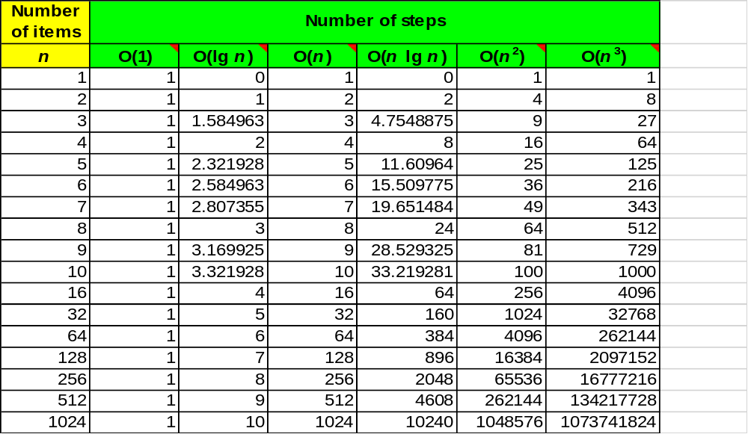
- Look over the following algorithms. Determine the order of complexity of each of the algorithms. Can you improve any of the algorithms to produce a better order of complexity?

Algorithm #1 for calculating the average of a list of values:
double average(list)
Given list, a list of values
Set total to 0
Set count to 0
For every value in list
Add value to total
Add 1 to count
Set average to total divided by count
Return average

Analyze based on time, with additions being the key step and n being the number of values in list. No worst-case since we just work on every value in list.
Shortcut analysis: There is one loop (For every value in list) which is done n times. Thus, the algorithm is O(n).
Detailed analysis: We have two assignments, then n*2 additions in the loop, then a division/assignment. Looking only at additions, there are 2n additions. Ignoring constants, the algorithm is O(n).

Algorithm #2.1 for calculating the sample variance s² of a list of values:
double variance1(list)
Given list, a list of values
Set variance to 0
Set count to 0
For every value in list
Set difference to value - average(list), where average(list) is calculated as above
Add difference * difference to variance
Add 1 to count
Set variance to variance divided by (count - 1)
Return variance

Analyze based on time, with operations (subtract, multiply, add) being the key step and n being the number of values in list. No worst-case since we just work on every value in list.
Shortcut analysis: There is one loop (For every value in list) which is done n times. However, in the loop, we calculate average(list), takes O(n) steps. Thus, the algorithm does n * n steps because the steps are nested, so it is O(n²).
Detailed analysis: We have two assignments, then n*4 operations in the loop (subtract, multiply and add, add), then a subtraction/division/assignment, but we also calculate average(list), which is O(n) in the loop, so it is involves n*n steps. Thus, we have n*4 + n² + 2 operations. Ignoring constants and lower orders, the algorithm is O(n²).
To improve this algorithm: Rather than doing average(list) in the loop, we can do Set avg to average(list) once before the loop (since the average never changes), then do Set difference to value - avg in the loop. The process then involves O(n) calculations before the loop and 4n calculations in the loop and 3 after, for a total of 5n + 3 calculations, which is O(n).

Algorithm #2.2 for calculating the sample variance s² of a list of values:
double variance2(list)
Given list, a list of values
Set count to 0
Set total to 0
For every value in list
Add value to total
Add 1 to count
Set squaresTotal to 0
For every value in list
Add value * value to squaresTotal
Set numerator to count * squaresTotal - total * total
Set denominator to count * (count - 1)
Set variance to numerator divided by denominator
Return variance

Analyze based on time, with operations (add, subtract, multiply) being the key step and n being the number of values in list. No worst-case since we just work on every value in list.
Shortcut analysis: There are two loops (For every value in list) which are each done n times. The loops are not nested, so there are n + n = 2n loops. Thus, ignoring constants, the algorithm is O(n).
Detailed analysis: We have two assignments, then n*2 additions in the loop, then another assignment, then 2n operations in the second loop (multiply, add), then 3 multiplies, 2 subtractions, and 1 division outside the loops. Thus, there are 2n + 2n + 6 = 4n + 6 operations. Ignoring constants, the algorithm is O(n).

See also Assignment #3 and the practice questions provided in class for Gauss-Jordan elimination, least squares, and other topics covered since the midterm.

